**PASSOVER**

**April 5 - April 13, 2023**

**Nissan 15 - 22, 5783**

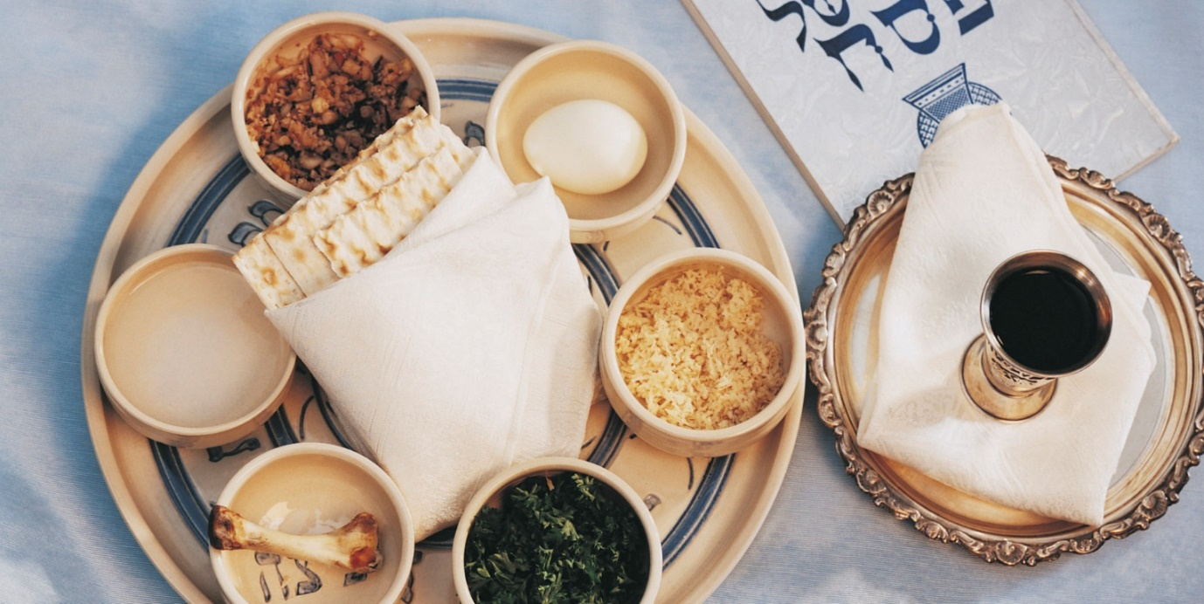

**A QUESTION AND ANSWER GUIDE  
TO PREPARING FOR PASSOVER**

I THE LAWS OF HAMETZ

A. DEFINITION OF HAMETZ (LEAVEN)

1. Hametz is any one of the following grains—oats, spelt, wheat, rye, and barley—that has come in contact with water for 18 minutes or more. This is the beginning of the leavening process.
2. Hametz can also be any food product, whether solid or liquid, that is produced from the above grains even if these grains are of the smallest quantities. (The only exception is matzah, when the dough does not come into contact with water for more than 18 minutes and the dough is baked in less than 18 minutes.)
3. Dishes, utensils, ovens, and ranges that have absorbed even the smallest amounts of hametz and hametz products are forbidden to be used during the week of Passover unless they are properly cleansed and kashered according to Jewish law.
4. It was the custom of Ashkenazic Jewry during the week of Passover not to eat rice, corn, and vegetables of the pea family as though they were really hametz. The reason for the custom was that the above vegetables were ground into flour to make bread. To avoid any confusion between these vegetables and the five hametz grains, the custom was created to abstain from eating these foods during Passover week.
   * Nowadays, there is little chance of this confusion. Eating these products, *as long as they are marked KOSHER FOR PASSOVER L’Ochlei Kitniyot*, “Kosher for Passover for those whose custom is to eat rice, corn, and vegetables of the pea family,” is not a violation of the Torah’s prohibition on Hametz. As noted above, Jews of non-European descent routinely eat these on Passover.
   * However, out of respect for people eating at your home, or in whose home you eat, ALWAYS ASK WHAT THEIR CUSTOM IS, and abide by it.
5. Any non-hametz food product that was prepared in vessels and utensils that did absorb hametz is prohibited to be eaten during Passover.

B. WHAT IS NOT HAMETZ?

1. The following types of food are not considered hametz in themselves:

a) Meat, poultry, and fish

b) Fruits and vegetables

c) Dairy products

1. The above mentioned non-hametz food categories must be processed, canned, bottled and packaged with rabbinic certification to guarantee that no hametz ingredient is included in the processing.

a) The following does not require any rabbinic certification:

1. Those foods written in Paragraph #1 in their raw or fresh condition

2. Refined sugar (excluding brown sugar, which does require supervision)

3. Salt

4. Ground coffee (excluding instant coffee)

1. Pure fruit juice without additives in a glass jar or bottle only
2. The prohibition against the use and consumption of hametz applies to those products that are edible and fit for human and animal consumption.
3. Those products that are made from hametz that are not edible and are not fit for both human and animal consumption are not considered hametz, and one may derive use and benefit from them. Some examples of such products are toothpaste, deodorants, hair sprays, shampoos, soaps, lipsticks, talcum & baby powder, and cold creams & hand creams. Although toothpastes and lipsticks do not require rabbinic certification for use during Pesach, one should only use a fresh tube of toothpaste with a new toothbrush and a fresh stick of lipstick.

**PLEASE NOTE**: Dishwashing liquids and soaps *must have rabbinic certification*.

C. THE SALE OF HAMETZ

The Torah teaches that during the eight days of Passover, Jews must not own or use any form of hametz. In the past, Jews would destroy all the hametz and hametz products before the Passover holiday or a Jew would give away all the leaven to a non-Jew as a gift that would be his permanent possession. However, Jews began to acquire much larger quantities of hametz for business or the home. The destruction or the giving away of these vast quantities of hametz would have meant a tremendous financial loss for Jews. The Rabbi's teach "Rachmana liba Be-ee." "The Law requires the heart." Jewish law gave us an alternative that has shown great compassion and understanding of the material needs of the Jewish community. This alternative is called "machirat hametz"—the selling of hametz.

The selling of the hametz is a legal business transaction with a non-Jew that involved the drawing up of a legal contract based upon rabbinic law and signed in the presence of two witnesses who also sign the contract. The contract includes an assessment of the value of the hametz being sold, a statement of the terms of delivery, and other conditions. The rabbi on Passover eve acts as the agent who will negotiate the sale with the non-Jew. The two people will reach an assessment of the value of the hametz, and the rabbi will ask for a down payment of money on the hametz. The rabbi will stipulate with the non-Jew that the balance of the money be paid on the night after the eighth day of Passover after the appearance of the stars. If, at that time, the non-Jew does not want to pay the balance, then the rabbi will return the deposit to the non-Jew and the sale will not be completed. This year, please do NOT eat the hametz you have asked the rabbi to sell on your behalf, until Thursday, **April 13th, 8:45 PM**. This will give the rabbi sufficient time to meet with the non-Jew who purchased our hametz.

This is a legal and binding sale and not a joke as some people claim. Any person who does desire to sell his or her hametz may come to the synagogue office or fill out the form below appointing the Rabbi as his or her agent in the sale of hametz. Please remember that the sale of the hametz is not reserved only for traditional Jews, but every Jew can participate in the mitzvah. Even if that person does not observe the traditions of Judaism in his or her home, the person should not feel ashamed but should try to do this mitzvah.

**PLEASE NOTE**: Even if one will be away from one's home during Passover, one is still obligated to sell his or her hametz.

# II KASHERING OF UTENSILS

The process of kashering utensils depends on how the utensils are used. According to halahkah, leaven can be purged from a utensil by the same process in which it was absorbed in the utensil (kevoleo kakh poleto). Therefore, utensils used in cooking are kashered by boiling, those used in broiling are kashered by fire and heat, and those used only for cold food are kashered by rinsing.

1. Earthenware (china, pottery, etc.) may not be kashered. However, fine translucent chinaware that has not been used for over a year may be used if scoured and cleaned in hot water.
2. Metal (utensils wholly made of metal) used in fire (spit, broiler) must first be thoroughly scrubbed and cleansed and then made as hot as possible. Those used for cooking or eating (silverware, pots) must be thoroughly scrubbed and cleaned and completely immersed in boiling water. Pots should have water boiled in them that will overflow the rim. The utensils should not be used for a period of at least 24 hours between the cleaning and the immersion in boiling water.
   1. Metal baking utensils cannot be kashered.
3. Oven and ranges: Every part that comes in contact with food must be thoroughly scrubbed and cleaned. Then oven and range should be heated as hot as possible for a half hour. If there is a broil setting, use it. Self-cleaning ovens should be scrubbed and cleaned and then put through the self-cleaning cycle. Continuous-cleaning ovens must be kashered in the same manner as regular ovens. A microwave oven, which does not cook the food by means of heat, should be cleaned, and a cup of water should be placed in it. Then the oven should be turned on until the water disappears. A microwave oven that has a browning element cannot be Kashered for Pesah.
4. Glassware: Authorities disagree as to the method of kashering drinking utensils. One opinion requires soaking in water for three days, changing the water every 24 hours. The other opinion requires only a thorough scrubbing before Pesah or putting it through a dishwasher.
5. Dishwasher: After not using the machine for a period of 24 hours, a full cycle with detergent should be run.
6. Electrical Appliances: If the parts that come into contact with hametz are removable, they can be kashered in the appropriate way (if metal, follow the rules for metal utensils). If the parts are not removable, the appliance cannot be kashered. (All exposed parts should be thoroughly cleaned.)
7. Refrigerators need only be thoroughly cleaned with warm water and soap. The racks don't need to be covered, but if you wish to use foil or wax paper, pierce it to allow air to circulate in the refrigerator.
8. Tables, closets and counters: If used with hametz, they should be thoroughly cleaned and covered, and then they may be used.
9. Kitchen sink: A metal sink can be kashered by a thorough cleaning and by pouring boiling water over it. A porcelain sink should be cleaned and a sink rack used. If, however, dishes are to be soaked in a porcelain sink, a dish basin must be used.
10. Hametz and non-Passover utensils - Non-Passover dishes, pots, and hametz whose ownership has been transferred should be separated, locked up, or covered, and marked to prevent accidental use.

# III THE SEARCH FOR THE HAMETZ

1. The Talmudic tractate known as "Massechet Pesahim" requires an intensive and careful search for hametz in one's house on the night before Passover as soon as possible after nightfall. This cleansing of the home before Passover is traditionally known as "bedikat chametz." This year, the search for hametz takes place on **Tuesday, April 4th** after sundown.
2. The supplies necessary for the search are:
   1. A candle
   2. Wooden spoon, paper bag, paper plate, or paper cup
   3. A feather
3. Since most of our homes are cleaned and ready for the Passover holidays, it is customary to place crumbs of bread in the various rooms of our homes (especially those rooms in which hametz was consumed) before the search.
4. Prior to beginning the search, the following blessing is recited:

"BARUCH AHTAH ADONAI, EHLOHAYNU MELECH HA'OLAM ASHER KID’SHANU BIH-MITZ-VOH-TAF, VIH-TZEE-VANU AL BEE UR HAMETZ."

"BLESSED ARE YOU, SOVEREIGN OF THE UNIVERSE, WHO HAS SANCTIFIED US THROUGH HIS COMMANDMENTS AND COMMANDED US CONCERNING THE DESTRUCTION OF THE HAMETZ."

1. The person then moves from room to room with a lit candle (please note: the house must be darkened) and gathers up the crumbs with the feather and places them in the wooden spoon or paper bag. No conversation is permitted until the search has been completed. The hametz that is found during the search is then tied up and put away so that it will be burned the next morning.
2. After the search has been completed, the person recites the following formula for nullification of the hametz preferably in the English language:

"ALL LEAVEN AND ALL HAMETZ THAT IS IN MY POSSESSION THAT I DID NOT SEE AND DID NOT DESTROY, LET IT BE NULL AND OWNERLESS AS THE DUST OF THE EARTH."

# IV FAST OF THE FIRST BORN

1. It is a tradition that on the day preceding Passover, the first-born sons of our people fast as an expression of thanksgiving to G-d for having spared the first born of the children of Israel from the plague that destroyed the first born of the Egyptians. This year the fast takes place on Wednesday April 8.
2. It is permissible for the first born to break the fast for the purpose of celebrating certain religious observances such as a wedding, a circumcision, or the completion of a tractate of the Talmud. In most instances, the Rabbis of many congregations will study a Talmudic tractate during the year and complete it on the eve of Passover. There are rejoicing and celebration when the Rabbi asks not only the first born, but everyone to participate in his simcha. The celebration is known as a "siyum.” The FJCC will have minyan and a study session on **Wednesday, April 5th at** **7:30 AM** for the Fast of the First Born.

# V BURNING OF THE HAMETZ

1. The book of Exodus tells us: "You shall destroy leaven from your houses." On the morning of Passover eve, the hametz that was collected during the bedikat hametz the evening before and other hametz is burned in a fire. The fire is normally lit outdoors, and the hametz is then thrown into the flames.
2. After the hametz is thrown into the flames, the following statement is said in English: "Any kind of leaven which is in my possession, whether I have seen it or not, whether I have destroyed it or not, shall be regarded as null and void and shall be as the dust of the earth."

No hametz may be eaten after **10:50 AM**, on **Wednesday, April 5th**. The burning of the hametz should take place on **Wednesday, April 5th**, before **11:50 AM**. There will be a community burning of Chametz at FJCC **after morning services that day (about 8:30 AM).**

***Form to Appoint an Agent to Sell My Chametz (Shtar Harsha’ah)***

I, (please print) _______________________________________________________________________, fully empower and permit Rabbi Eric Cohen as my agent to act in my place and in my behalf to sell all my chametz and chametz mixtures as defined by the Torah and Rabbinic Law and to lease all places wherein the chametz owned by me may be found, especially in the premises located at (please print addresses):

Home: ______________________________________________________________________________

Work: _______________________________________________________________________________

Other: _______________________________________________________________________________

______________________________________________________________________________

______________________________________________________________________________

The Rabbi has full power to sell and to lease by transactions as he deems fit and proper for such times as he believes necessary in accordance with all detailed terms and forms according to Jewish law. Also, I do hereby give the Rabbi full power and authority to appoint a substitute in his stead with full power to sell and lease. This is meant to conform with all the Torah and Rabbinic regulations and laws, and to be in accordance as well with the laws of the State of New Jersey and of the United States of America.

_____________________________________________________________________________________

Signature Date

**PASSOVER SCHEDULE OF SERVICES** (Zoom options)

Search for Chametz

Tuesday, April 4th At home, in the evening

EREV PASSOVER

Wednesday April 5th

Services for Fast of the First-born 7:30 AM

Burn Chametz After morning services (no later than 11:50 AM at home)

*Stop Eating Chametz* 10:50 AM

FIRST DAY OF PASSOVER

Wednesday April 5th

Evening services 6: 00 PM

Candle lighting 7:10 PM (prepare flame from which to light next days’ candles)

1st Seder

Thursday, April 6th

Morning services 9:15 AM

SECOND DAY OF PASSOVER

Thursday, April 6th

Evening services 6:00 PM

Candle lighting 8:19 PM (from existing flame, or non-electric pilot light)

2nd Seder

Friday, April 7th,

Morning services 9:15 AM

SHABBAT CHOL HAMOED

Friday April 7th

Candle lighting 7:12 PM (from existing flame, or non-electric pilot light)

Evening services 7:30 PM

Saturday April 8th

Morning services 9:15 AM

7th DAY PASSOVER

Tuesday, April 11th

Candle lighting 7:16 PM (prepare flame from which to light next days’ candles)

Evening Services 7:30 PM

Wednesday, April 12th

Morning services 9:15 AM

Candle lighting 8:25 PM (from existing flame, or non-electric pilot light)

8TH DAY OF PASSOVER

Thursday, April 13th

Morning services 9:15 AM

YIZKOR 10:30 AM (an estimate, come earlier)

PASSOVER ENDS

Thursday, April 13th 8:18 PM

Post-Passover Pizza Party @ Al Fresco 8:30 PM (**please**: do *not* eat the Chametz in your home until 8:45 PM)